NAME : KAJAL KUMARI AGE : 22 M/ F
Refd. By DR.: AIIMS DATE OF REPORT: 16 January, 2026
==============================================================================
PLAIN M.R.I. STUDY OF BRAIN
CLINICAL INDICATION22-year-old patient presenting with a history of headache.
TECHNIQUE Multiplanar, multi-sequence imaging of the brain was performed including T1, T2, FLAIR, DWI, and GRE/SWI sequences.
FINDINGS
Brain Parenchyma:
- White Matter: There are few, tiny, discrete foci of T2 and FLAIR hyperintensity noted in the bilateral periventricular white matter. These lesions appear isointense on T1-weighted images. There is no evidence of perilesional edema or mass effect.
- Gray Matter: The cortical gray matter and deep gray matter nuclei (basal ganglia and thalami) are unremarkable.
- Brainstem & Cerebellum: The brainstem and cerebellar hemispheres show normal signal intensity and morphology. No infratentorial lesions are seen.
Diffusion Weighted Imaging (DWI) & Gradient Echo (GRE/SWI):
- No areas of restricted diffusion or blooming artifacts are identified to suggest acute ischemic infarction hemorrhage, calcification, or cavernous malformations.
Ventricles and CSF Spaces:
- The lateral, third, and fourth ventricles are normal in size, shape, and position. The basal cisterns and cortical sulci are patent and appropriate for the patient's age. No midline shift or hydrocephalus is evident.
Vascular Structures: Major intracranial vascular flow voids are preserved.
Extra-axial Structures:
- The sella turcica and pituitary gland appear normal. The orbits and calvarium are unremarkable.
IMPRESSION
- Few non-specific, discrete T2/FLAIR hyperintense foci in the bilateral periventricular white matter.
  - ? migraine-related microvascular changes (gliosis).
- No acute infarction, intracranial hemorrhage, or space-occupying lesion.

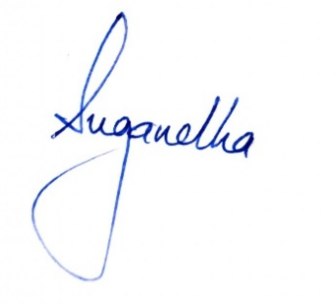
Follow-up MRI in 6–12 months to assess for stability is recommended.

